AI-Controlled 3D-Printed Prosthetic Hand
with Adaptive Grip-Force Control

Team 15
Supervisor: Dr. Aliaa Rehan

Student Name | ID
Mohamed Harras | 9221100
Mohamed Ashraf | 9170499
Omar Khaled | 9220536

Problem Statement

Restoring a functional grasp in low-cost upper-limb prostheses remains difficult because affordable myoelectric systems still depend mainly on gesture-based control. Such systems can detect that a user intends to open or close the hand, but they do not regulate how much force is applied during contact. Insufficient force may cause slippage, whereas excessive force can damage delicate objects. Commercial myoelectric hands with richer control are often expensive. In this project, we aim to develop an affordable 3D printed prosthetic hand that can estimate and modulate grip force continuously using as few EMG signals as possible.

Viable and Feasible solution

The proposed solution is an AI-controlled, EMG-based proportional grip-force control system. The prosthetic hand is based on the open-source InMoov hand, actuated by five SG90 servo motors and nylon tendons, with force measurement provided through a load-cell mechanism for closed-loop regulation. The hardware design also includes an Arduino-based controller. To keep the system low-cost, only two forearm channels were used after Minimum Redundancy Maximum Relevance (mRMR) analysis showed that the extensor carpi radialis brevis and extensor carpi ulnaris muscle signals as the most informative. This architecture reduces sensor count, simplifies electrode placement, and remains feasible for embedded implementation.
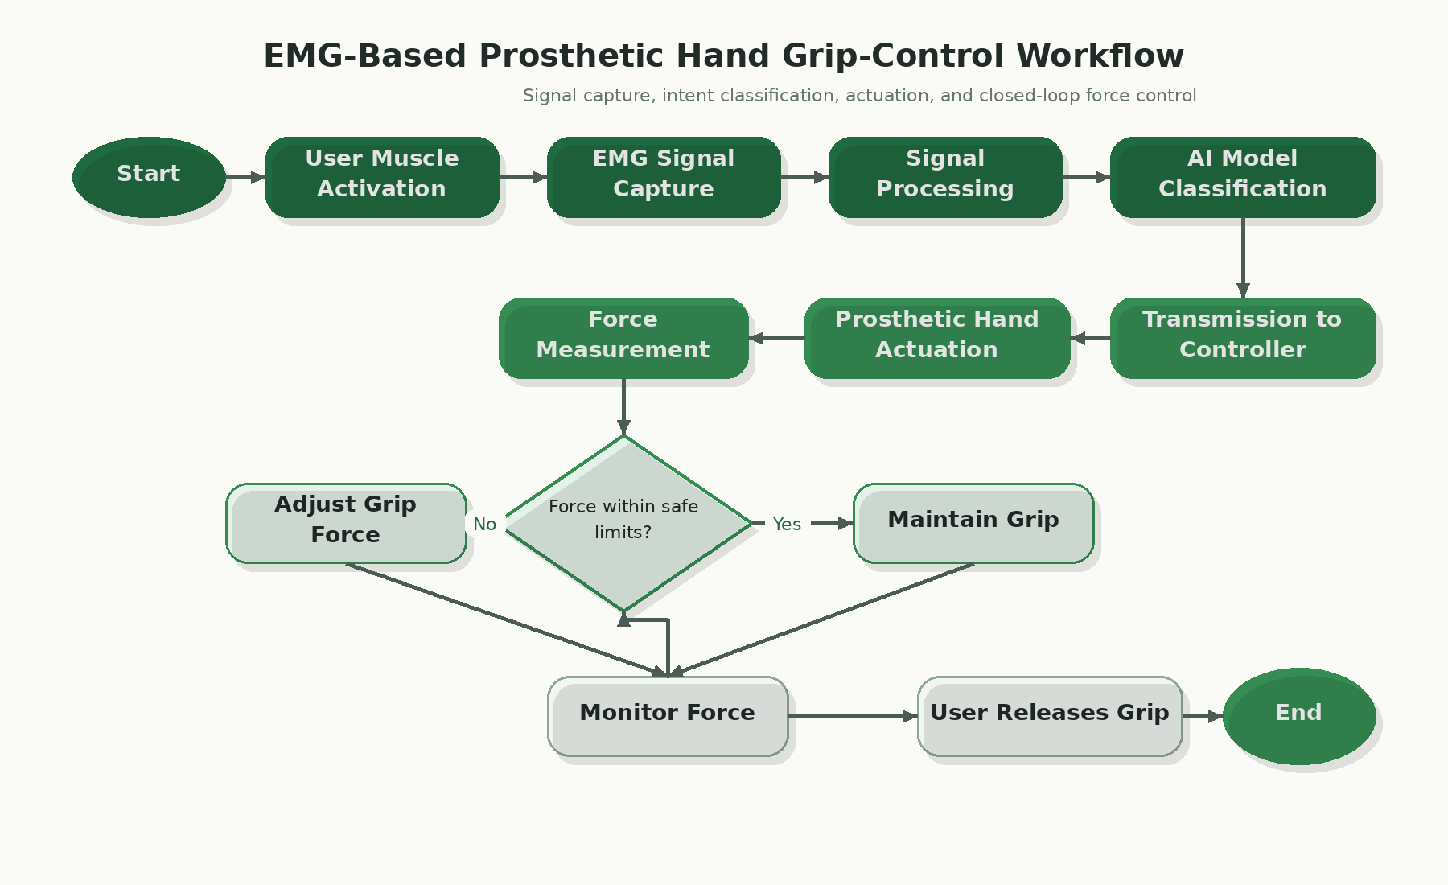

Figure 1. Closed-loop architecture of the proposed prosthetic hand, showing two-channel sEMG acquisition, 36-dimensional feature extraction, GRU-based force estimation, and load-cell-guided grip correction.

Steps Taken

After mRMR-based channel selection, data from 9 subjects in the EMG dataset (Ghorbani et al., 2023) were segmented into 100 ms windows with a 20 ms hop, and six time-domain features were extracted from each channel together with first- and second-order derivatives to form a 36-dimensional feature vector. These features were used to train three models: GRU (Gated Recurrent Unit), MLP (Multil Layer Perceptron), and Ridge regression. All three models were tested, and the GRU achieved the best result with an average R² of 0.78 ± 0.062, an NRMSE of 11.5 ± 1.8%, and a Pearson correlation coefficient of 0.890 ± 0.033, compared with MLP (R² = 0.73) and Ridge (R² = 0.69), so it was selected for the final system. The predicted force was then converted into actuator commands and continuously checked against the force feedback signal, as illustrated in Figure 1. The scatter plot in Figure 2 shows points clustered around the identity line, indicating that predicted force values track the measured force consistently.
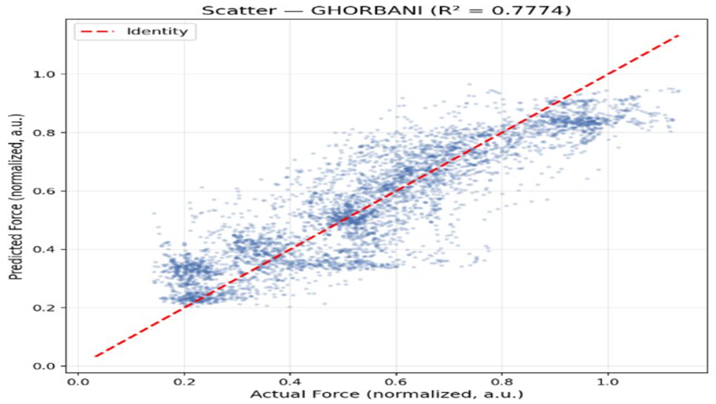
Figure 2. Predicted-versus-actual normalized grip force on the Ghorbani dataset; clustering near the identity line supports the regression performance of the proposed model.

Conclusion

Bridging the gap between the problem and the proposed solution requires an integrated methodology combining literature review, signal processing, model development, and hardware implementation. The system drew on prior studies on printed prosthetic hands, minimal-channel EMG sensing, and force-feedback control Model validation will be done in healthy subjects using a load cell embedded in a 3D printed cylinder. Future testing should also include amputee participants and further adaptive control refinements. The project provides proof of concept for an affordable prosthetic hand with machine learning and embedded control.

References
[1] Segura, Diego, et al. “Upper Limb Prostheses by the Level of Amputation: A Systematic Review.” Prosthesis, vol. 6, no. 2, 19 Mar. 2024, pp. 277–300, https://doi.org/10.3390/prosthesis6020022.
[2] “Main Types of Upper Limb Prostheses.” Horton’s Orthotics & Prosthetics, 3 June 2025, www.hortonsoandp.com/main-types-of-upper-limb-prostheses/.
[3] Chen, Ziming, et al. “A Review of Myoelectric Control for Prosthetic Hand Manipulation.” Biomimetics, vol. 8, no. 3, 1 July 2023, p. 328, www.mdpi.com/2313-7673/8/3/328, https://doi.org/10.3390/biomimetics8030328.
[4] Kalita, Amlan Jyoti, et al. “Functional Evaluation of a Real-Time EMG Controlled Prosthetic Hand.” Wearable Technologies, vol. 6, 2025, www.cambridge.org/core/journals/wearable-technologies/article/functional-evaluation-of-a-realtime-emg-controlled-prosthetic-hand/C33453286AE62A2E0799255536F42AB4, https://doi.org/10.1017/wtc.2025.7.
[5] Arbaud, Robin, et al. “Learning and Online Replication of Grasp Forces from Electromyography Signals for Prosthetic Finger Control.” ArXiv.org, 2025, arxiv.org/abs/2505.02574. Accessed 16 Mar. 2026.
[6] Wu, Longhan, and Qingcong Wu. “An Adaptive Grasping Multi-Degree-of-Freedom Prosthetic Hand with a Rigid–Flexible Coupling Structure.” Sensors, vol. 25, no. 19, 1 Oct. 2025, pp. 6034–6034, www.mdpi.com/1424-8220/25/19/6034, https://doi.org/10.3390/s25196034.
[7] Chen, Ziming, et al. “Tactile Sensing Enables Shared Control of Prosthetic Hand with Multi-Stage Grasping and Force Level Switching Functions.” Tsinghua Science and Technology, vol. 31, no. 1, Feb. 2026, pp. 639–657, https://doi.org/10.26599/tst.2025.9010070. Accessed 18 Nov. 2025.
[8] Xu, Xiaolei, et al. “Compliant Grasp Control Method for the Underactuated Prosthetic Hand Based on the Estimation of Grasping Force and Muscle Stiffness with SEMG.” Biomimetics, vol. 9, no. 11, 27 Oct. 2024, pp. 658–658, https://doi.org/10.3390/biomimetics9110658. Accessed 4 Mar. 2025.
[9] Neeraj Sharma, Aryan Jadhav, Alok Prakash, and Shiru Sharma, “Development of Low-Cost Myoelectric Prosthetic Hand with Force Feedback,” 2024 9th International Conference on Integrated Circuits, Design, and Verification (ICDV), June 2024, doi: 10.1109/ICDV61346.2024.10616604.

